Press release: AyeAye Systems and

HMP Tech Group partner on AI and

DT assisted Navigation Project

Den Helder 27-05-2024

AyeAye Systems and HMP Tech Group are partnering on the groundbreaking "wAve-I" project, made possible by the prestigious MIT R&D subsidy. This collaborative endeavour aims to revolutionise maritime navigation through the development of a digital boat twin empowered by artificial intelligence and machine learning.

Project Overview and Subsidy Acquisition
The "wAve-I" project sets out to create a sophisticated platform capable of visualising and predicting sea conditions with unparalleled accuracy. By harnessing a combination of local sensors, radar data, and cloud-based information, the digital boat twin will provide real-time insights into critical factors such as wave height, direction, and speed. Moreover, it will offer valuable predictions regarding the impact of navigation decisions on crucial parameters like estimated time of arrival (ETA), fuel consumption, heading, and overall sea state.

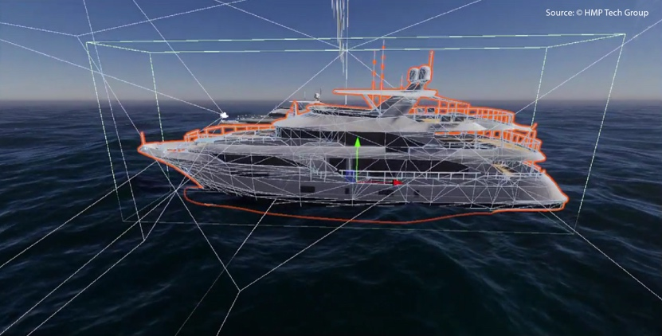

About AyeAye Systems and HMP Tech Group
"We are thrilled about the opportunities that the 'wAve-I' project brings," remarked Jamos Tan, Founder of AyeAye Systems. "This collaboration represents a significant step forward in maritime technology, offering ship operators an unprecedented level of situational awareness and decision-making support. The 'wAve-I' project embodies our shared vision of leveraging AI and machine learning to enhance safety, efficiency, and sustainability in maritime navigation." Hamed Mehdipoor, CEO of HMP Tech Group, echoed Tan's sentiments, stating, "Our partnership with AyeAye Systems underscores our commitment to pushing the boundaries of innovation in the maritime industry. The ‘wAve-I’ project highlights the potential of Digital Twin technologies."

Focus on AI and DT assisted Navigation and Novelty of Development
The goal of the "wAve-I" project is to equip vessels with a virtual captain boasting centuries' worth of experience, enabling safer, more efficient, and environmentally conscious maritime operations.
AyeAye Systems and HMP Tech Group are eager to embark on this transformative journey, confident that their collaboration will redefine the future of navigation at sea.

For media inquiries, please contact:
Leonie Nora Tan, Marketing Manager at AyeAye Systems, press@ayeaye.systems

